User's Guide for working with "Internet Banking for Legal Entities" system of Correqts Corporate 2.3.

City of Almaty, 2020

Table of contents
Chapter 2. Accounts and cards 4
2.1. Accounts 4
2.1.1. Request for statement 4
2.1.2. Viewing statements 6
2.1.3. Export of statement for the period 7
2.2. Cards 8
2.1.1. Viewing information on corporate cards 8
Chapter 3. Incoming payments 10
3.1. Viewing incoming payment 10
3.2. Export of incoming payment to MT format file 11
Chapter 4. Card index sheet 12
4.1. Working with card index sheet directory 12
Chapter 5. Contributions (under development) 12
Chapter 6. Payment documents 12
6.1. Creation of payment order 12
6.2. Creation of salary payment 16
6.3. Creation of pension payment 18
6.4. Creation of social payment 19
6.5. Import of documents 20
Chapter 7. Foreign exchange transactions 23
7.1. Creation of currency purchase order 23
7.2. Generation and sending of currency selling orders for processing 25
7.3. Generation and sending of currency conversion orders for processing 26
7.4. Generation and sending of currency transfers for processing 26
Chapter 8. Covered guarantees (under development) 31
Chapter 9. Foreign exchange contracts (under development) 31
Chapter 10. Credit documents (under development) 31
Chapter 11. Letters to the bank 32
11.1. Letters to the bank 32
11.2. Letters from the bank 33

Chapter 1. Home page
The "Home page" in the workspace provides the most important information necessary for the user. When logging into the system, the home page is displayed in the workspace of the main window immediately after authorization in the system. During the work session, the user can return to the home page by selecting "Home" in the main menu.
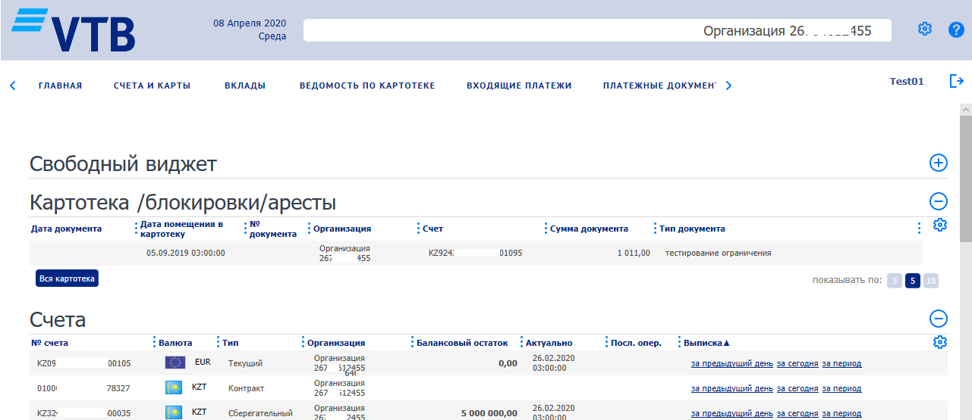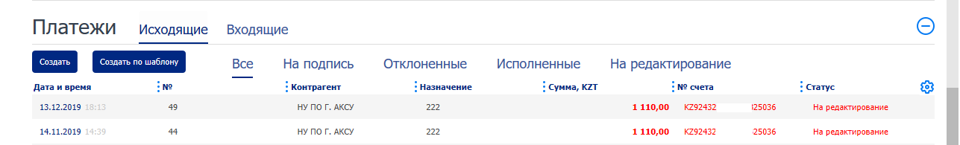
Figure 1

Chapter 2. Accounts and cards

2.1. Accounts

2.1.1. Request for statement
2.1.1.1. Creation and sending of requests for statement for processing
To create and send requests for statement for processing:
- Select "Accounts", $→$ "Request for statement".
- This will open the "Request for statement" list form.
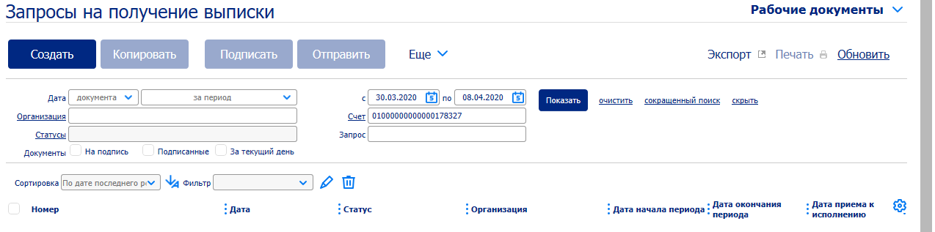
Figure 2
To create a request for statement:
1. Press the "Create" button of the toolbar in the form of Request for statement.
2. This will open the "Request for statement" window (Figure 3).
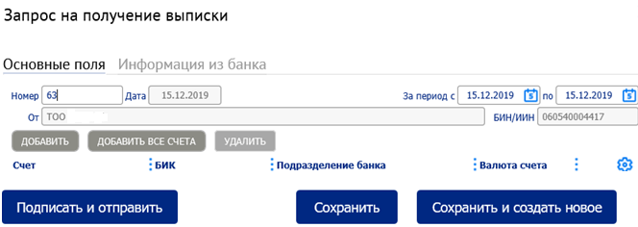
Figure 3
A number of fields in the window will be already filled in by the system. Fields with a white background are filled in or edited manually. Fields with a grey background are filled in either by the user by selecting values from the list, or automatically by the system after filling in the related fields.
3. Enter or edit details value:
- If necessary, change the document number in the Number field. By default, the system numbers the documents in the order they were created during the calendar year.
- If necessary, change the period for which the information is requested:
A. If necessary, change the start date of the period in the "For the period from" field. By default, the field is filled in with the current date.
B. If necessary, change the end date of the period in the "to" field. By default, the field is filled in with the current date.

4. Create a list of accounts for which you want to get information about cash flow. To add a single account record – press the "Add" button, to add all account records – press the "Add all accounts" button, to delete – press the "Delete" button.
5. To save, sign and send the created document to the bank, press the "Sign and send" button.

2.1.2. Viewing statements
To view statements:
- In the navigation area, select "Accounts" $→$ "Statement".
- This will open the "Statement" list form.
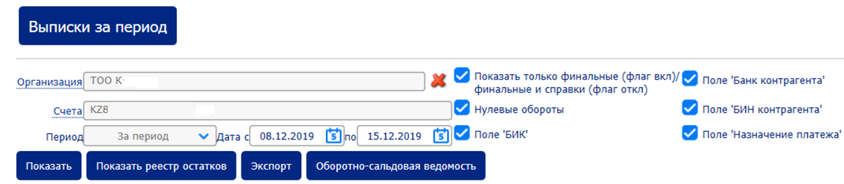
Figure 4
- If the current user can work with statements of several organizations, enter the organization for which you want to display the list of generated statements in the "Organization" field by selecting the required one in the organization directory.
- Or enter BIN/IIN of the organization in the BIN/IIN field, selecting the required value from the organization directory.
- In the "Accounts" field, select the accounts for which you want to display the generated statements:
- Open the Account directory window by following the link in the field name.

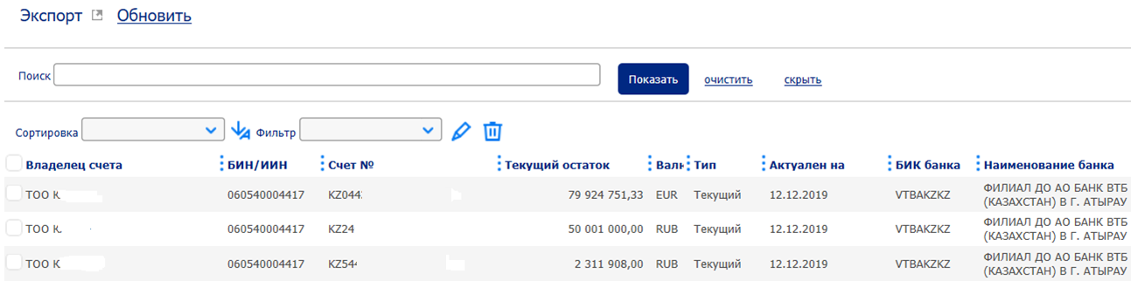
Figure 5
- In the opened window, select those accounts, for which export of statements is required, by checking the appropriate fields.
- To select all accounts, check the Account holder selection field.
- Press the OK button to save the selection, or the Cancel button to cancel the selection of accounts.
- The selected accounts will be displayed in the Accounts field of the Statement list form.
- In the Period drop-down list, enter the type of period for which you want to display the generated statements.
- In the Date from field, enter the start date of the period, for which you want to display the generated statements.
- In the to field, enter the end date of the period for which you want to display the generated statements.
- Check the Show only final statements/certificates selection field if you want to display only final statements or certificates.
- Check the Zero turnovers selection field if you want to display statements with zero turnovers.
- Check the 'BIC' selection field if you want to display the BIC field in the list of statements.
- Check the 'Counterparty's bank' selection field if you want to display the Counterparty's bank field in the list of statements.
- Check the 'Counterparty's BIN' selection field if you want to display the Counterparty's BIN field in the list of statements.
- Check the 'Payment purpose' selection field if you want to display the Payment purpose field in the list of statements.
- As a result, this will display the list of all statements for the specified period, indicating payment documents, on the basis of which the cash flow was carried out.

2.1.3. Export of statement for the period
To export statements for the period, perform the following operations:
1. Press the Statements for the period button.
2. This will open Export of statements for the period window.
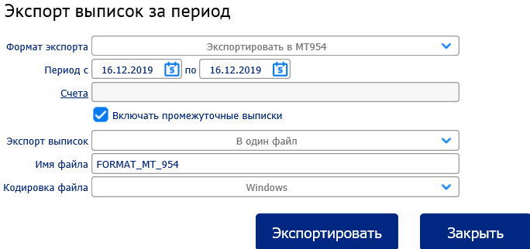
Figure 6
3. Fill in the following fields in the opened window:
a. Select the required statement export format from the Export format selection list.
b. In the Period from field, enter the beginning of the period, in the to field, enter the end of the period for which the statements are exported.
c. In the Accounts field, enter the accounts for which statements are exported, using the Selection of values window.
d. If you also want to export interim statements, check the Include interim statements selection field.
e. In the Export of statements selection list, select the export option
• To one file – all statements for the specified period will be exported as a single file.
• To different files – each statement will be exported as a separate file.
f. In the File name field, enter the export file name.
g. From the File encoding selection list, select an encoding for the export file to be saved.
4. Complete the export procedure:
• Press the Export button to complete the export of statements for the specified period for the specified accounts in the set format.
• Press the Cancel button to abort the export procedure.

2.2. Cards

2.1.1. Viewing information on corporate cards
To view information on corporate cards of your organization:
1. Select the Accounts & cards → Cards → Cards from the main menu.
2. The workspace will display the infographics of Cards.

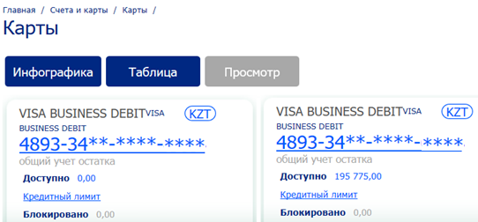
Figure 7
3. Select a convenient form to display the information:
While staying in the infographics, view the basic data of cards (number, currency, available limit, etc.) on separate icons.
a. To view detailed information on a separate card:
A. Double click on the card number on the icon of the required card.
B. This will display the Corporate card window with full detailed information on the card.
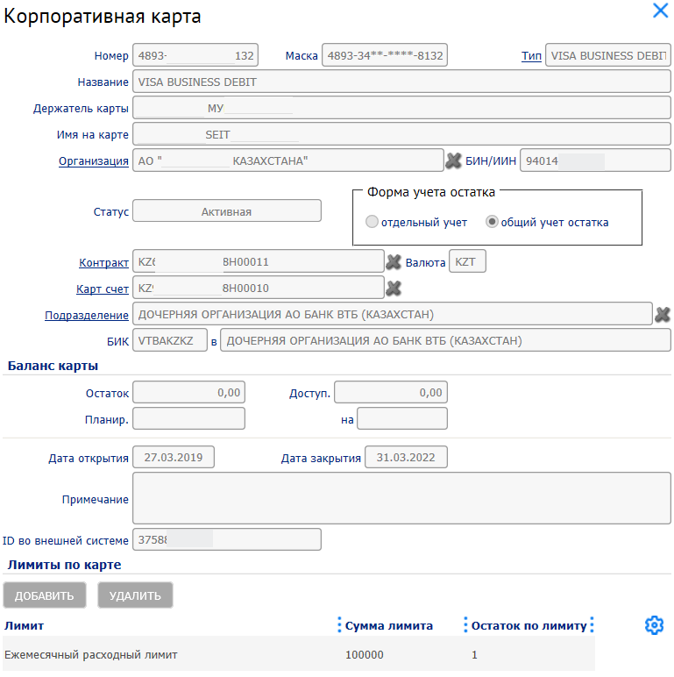
Figure 8
To view only the information about credit limit of the selected card:
A. Double click on the Credit limit hyperlink on the icon of the required card.
B. This will display the Limits for the payment card window with information about this card limits.
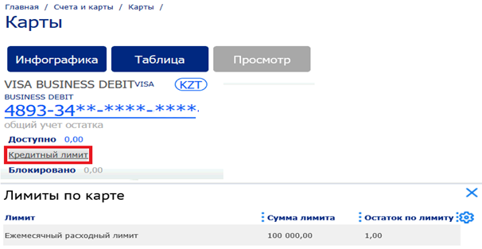
Figure 9
To switch to the tabular form:
a. Press the Table button.
b. This will display the Cards list form.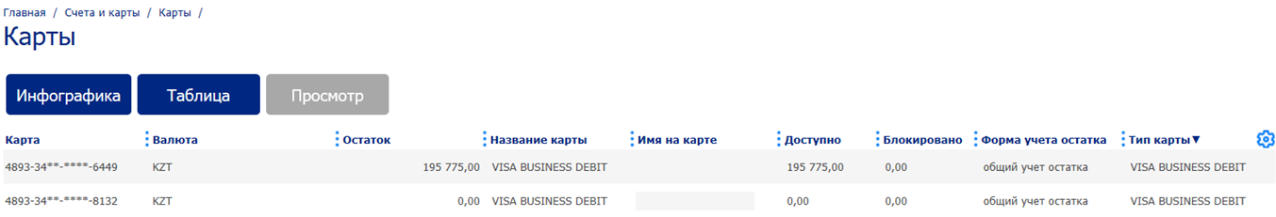
Figure 10
Look through the main card data in the form table.
d. To view detailed information on a separate card:
A. Select the required card in the list and press the View button or double click on the appropriate card.
B. This will display the Corporate card window with full detailed information on the card.
As a result of these actions, information about the corporate cards connected to your organization will be viewed.

Chapter 3. Incoming payments

3.1. Viewing incoming payment
To view the incoming payment:
1. In the list form of incoming payments, select the required document and press the View button.
2. This will open the Incoming payments window.
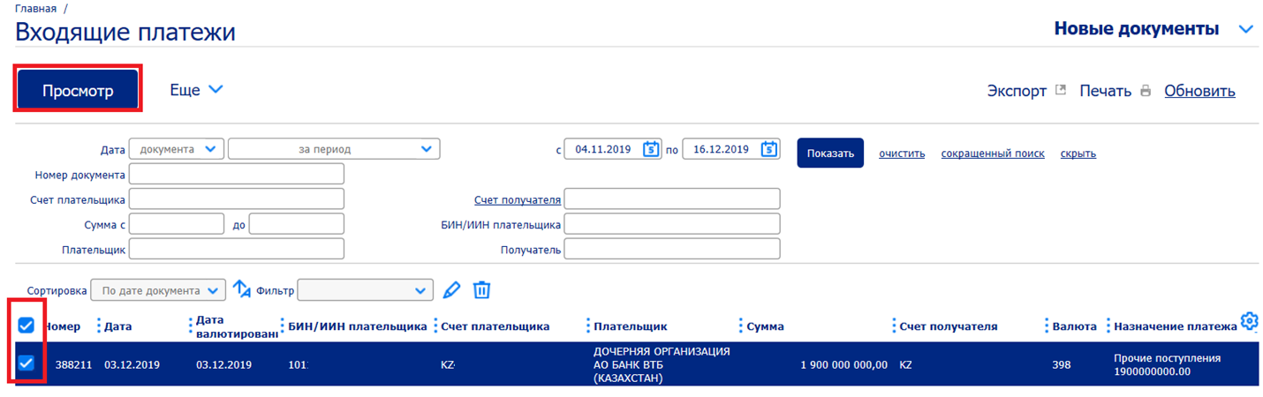
Figure 11
Select the necessary account(s) to view by checking, then "View".
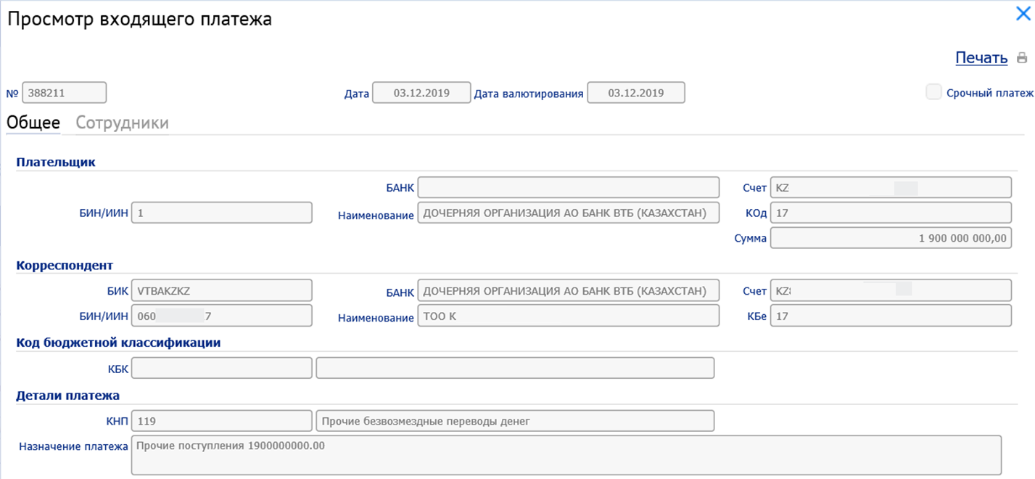
Figure 12.

3.2. Export of incoming payment to MT format file
For payment to MT format file:
1. In the list form of incoming payments select the required document / documents and press the "Export" → "Export document to MT" hyperlink.
2. This will open the "Export of incoming payments" window.
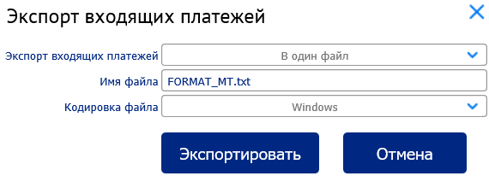
Figure 13
3. If necessary, change the default export settings:
- In the Export of incoming payments field select the option of export to one common file or a separate file.
- In the "File name" field, change the mask of the file name.
- In the File Encoding field, select the text encoding in the export file / files.
4. Press the "Export" button.
5. The system will create a zip archive with the file / files containing the exported data and display a typical request for your browser to save / open the archive.
6. Save the zip archive.
7. To return to the list form of incoming payments, press "Cancel" button. As a result of these actions, they will be exported to file / files of MT format.
Note
When exporting to different files, a sequence number will be automatically added to the specified file name.

Chapter 4. Card index sheet

4.1. Working with card index sheet directory
To work with the card index sheet directory:
1. Select "Card index sheet" from the main menu.
2. The workspace will display a form of card index sheet directory.
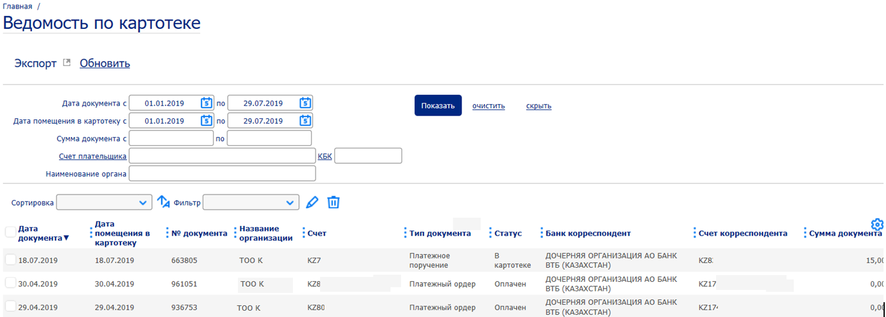
Figure 14
3. Look through the list of directory records. If necessary, export the list of directory records to XLS format using the "Export" → "Export of list to XLS" element.
As a result of these actions, the records of the card index sheet directory will be viewed and/or exported to XLS format.

Chapter 5. Contributions (under development)
The functionality of the Deposit option is currently under development.

Chapter 6. Payment documents

6.1. Creation of payment order

To create a payment order:
- In the list form of payment documents, press "Create" button on the toolbar and select "Payment order" in the drop-down list.

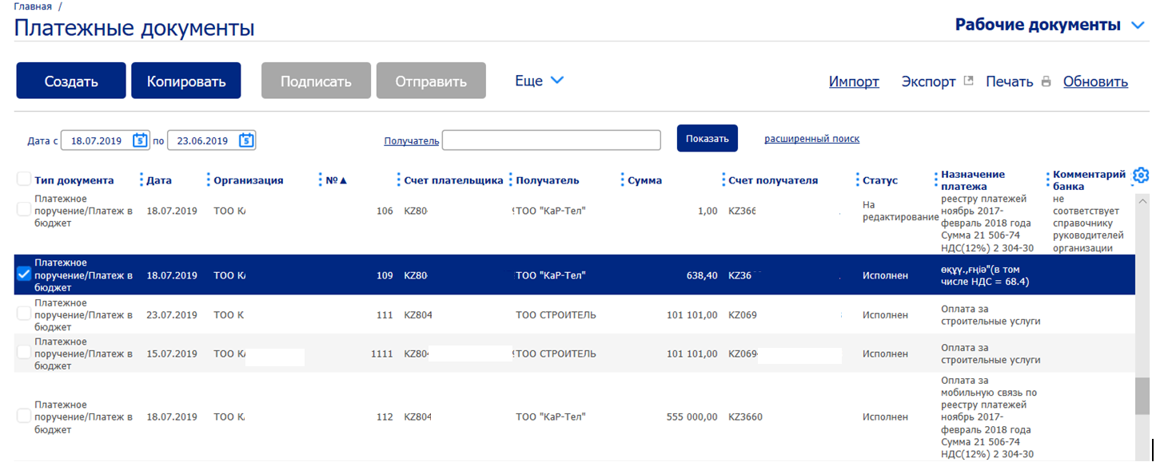
Figure 15
- This will open "Payment order/Payment to budget" window.
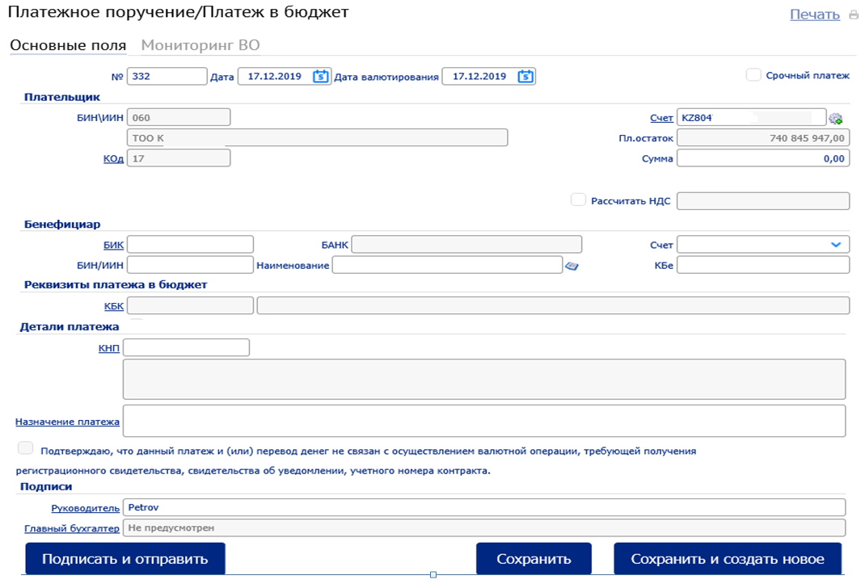
Figure 16
A number of fields in the window will be already filled in by the system. Fields with white background are filled in or edited manually. Fields with grey background are filled in either by the user by selecting values from the list, or automatically by the system (particularly after filling in the related fields).
Attention!
• To select values from directories, it is necessary to call the required directory by pressing on the hyperlink in the name of the appropriate field.
• Values can be selected from drop-down lists by pressing the button
• Dates can be entered either manually or by pressing the button
Filling in/editing of document:
Enter or edit the values of the payment order details:
Change the document number in the No. field if necessary. By default, the system numbers the documents in the order they were created during the calendar year.
In the Date field, change the document date if necessary. By default, the field is filled in with the current date.
In the Value date field, enter the value date if necessary. By default, the field is filled in with the current date.
If it is necessary to make an urgent payment, fill in the Urgent payment selection field.
Note:
If the Urgent payment field is filled in, the Value date field is automatically filled in with the current date.
In the Payer box, enter or edit the values of the payer's details and the amount of payment:
A. If necessary, change the payer's account details:
1. In the Account field, change the account number (select from the account directory or enter manually).
2. The BIN\IIN, Payer's name, Code, Payment balance fields will be filled in automatically.
In the Amount field, enter the amount of payment.
If necessary, fill in the "Calculate VAT" field. The system will automatically calculate the VAT value and display it in the VAT field.
In the Beneficiary box, enter the values of correspondent's details using one of the following methods:
If the information about the beneficiary was earlier entered in the beneficiary directory:
Select a recipient from the beneficiary directory (search for a recipient by the value of the BIN field is also available) by pressing the button.
"BIN\IIN", "Name", "Account", "BANK", "BIC", "Beneficiary code" fields will be filled with values from the directory.
If the recipient is not in the beneficiary directory (new recipient), fill in the appropriate fields manually:
Enter the data about the beneficiary's bank:
1. In the BIC field, enter or select BIC from the directory of Kazakhstan banks.
2. The Recipient's bank field will be filled in automatically.
In the BIN\IIN field, enter the recipient's BIN/IIN or IIN.
In the Account field, enter the beneficiary's account number.
In the Name field, enter the name of the beneficiary organization.
In the Beneficiary code field, enter the beneficiary code of the beneficiary organization.
In the Payment details box, enter the payment purpose:
If the payment under this document is a tax payment (BIC field indicates BIC of the Treasury Committee), the Budgetary classification code field will be available for filling in. In this case, select a record from the Budgetary classification code directory containing the required budgetary classification code value. The name of the Budgetary classification code will be automatically displayed in the field on the right.
The Recipient's bank field will be filled in automatically.
In the BIN\IIN field, enter the recipient's BIN/IIN or IN.
In the Account field, enter the beneficiary's account number.
In the Name field, enter the name of the beneficiary organization.
In the Beneficiary code field, enter the beneficiary code of the beneficiary organization.
In the Payment details box, enter the payment purpose:
If the payment under this document is a tax payment (BIC field indicates BIC of the Treasury Committee), the Budgetary classification code field will be available for filling in. In this case, select a record from the Budgetary classification code directory containing the required budgetary classification code value.
- The name of the Budgetary classification code will be automatically displayed in the field on the right.
- In the Payment purpose field, enter the payment purpose value manually or select a record from the Uniform payment purpose classifier directory.
The Payment purpose field will be automatically filled in with the name of the payment purpose code. If necessary, this information can be edited.
In the Payment purpose field, enter the name of payment purpose code, if it has not been done automatically.
In the Contract ID field, enter the currency contract ID if necessary, on the basis of which the payment order is created.
In the Registration certificate/certificate of notification field, enter the number of registration certificate or certificate of notification if necessary.
If the payment order being created does not require obtaining a registration certificate, certificate of notification or contract ID, fill in the appropriate item "I do confirm that this payment and/or money transfer is not related to the foreign exchange transaction that requires obtaining a registration certificate, certificate of notification, contract ID".
In the Signature box, change the details of the authorized persons indicated automatically if necessary:
In the Manager field, enter manually or select the name of chief executive officer from the directory.
In the Chief Accountant field, enter manually or select the name of the Chief Accountant from the directory.
Attention!
If the organization has only a Manager (no Chief Accountant), you do not need to fill in the Chief Accountant field.
- Complete the document creation:
- Save, sign and send the created document to the bank:
- Press the "Sign and send" button.
The system will check if the fields are filled in correctly, after that:
If there are no errors and no comments, the system will offer you to sign it, and if your signature authority is enough to fully sign this document, send the document to the bank. After completion of signing the document, the generated document will appear in the list of payment documents with the status "Signed".
If there are any errors and/or warnings, the "Verification results" window containing the list of warnings and error messages will be displayed.
Note
Blocking errors that do not allow to save the document will be marked with icons, errors that allow to save the document in the status "For correction" (for future editing) – with icons , non-critical remarks, at which further processing and sending of the document (warnings) is allowed – with icons .
In this window: To return to editing and make necessary corrections:
Press the "Close" button to return to the document window. You will be returned to the document window.
To save the document with the current details values for future editing (if there are no blocking errors):
Press the "Save" button.
You will be returned to the list of documents in the workspace.
The generated document will appear in the list with the status "New" (if there are only warnings) or "For correction" (if there is at least one error). As a result of these actions, the document will be created and saved.

6.2. Creation of salary payment
To create a salary payment:

1. Press the "Create" button in the list form of payment documents on the toolbar, and select the "Salary payment" from the drop-down list.
2. This will open the "Salary payment" window.
A number of fields in the window will be already filled in by the system. Fields with a white background are filled in or edited manually. Fields with grey background are filled in either by the user by selecting values from the list, or automatically by the system (particularly after filling in the related fields).
Filling in the Salary payment details is similar to the "Payment order/Payment to budget" form, which is described in sub-paragraph 2 of paragraph 6.1. Chapter 6. Payment documents.

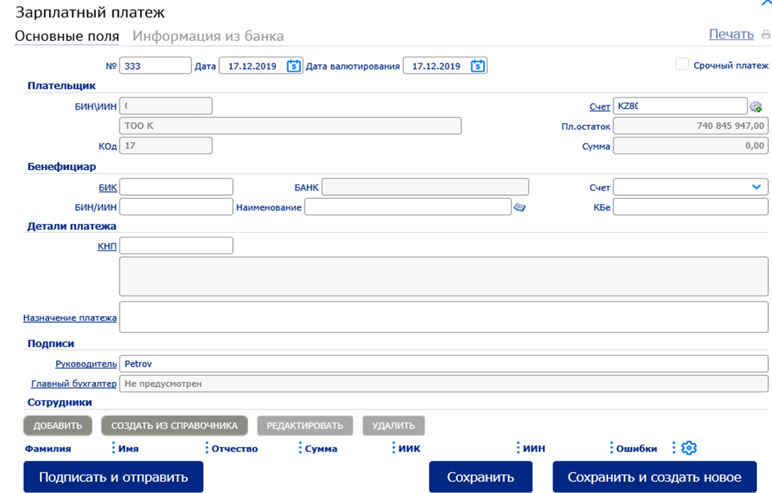
Figure 17
In the "Employees" box, enter information about the employees receiving salary within this payment and the amount of payments to each of them:
A. Press the "Add" button on the box's toolbar.
B. This will display the window of entering information about the employee.
In this window:
1. In the "Last name" field, enter the last name of the employee.
2. In the "First name" field, enter the first name of the employee.
3. In the "Patronymic" field, enter the patronymic of the employee if necessary.
4. In the "Amount" field, enter the amount of payment to this employee.
5. In the "Personal/card account (IIC)" field, enter the IIC of this employee.
6. In the "IIN" field, enter the IIN of this employee.
7. Save a record about the employee:
a. Press the "Save" button.
b. The system will check if the fields are filled in correctly, after that:
• If there are no errors or comments, you will be returned to the "Salary payment" window. The record about the employee will appear in the table of the "Employees" box.
• If there are errors and/or warnings, the "Verification results" window will be displayed
After that, save, sign and send the created document to the bank by pressing on the "Sign and send" button.
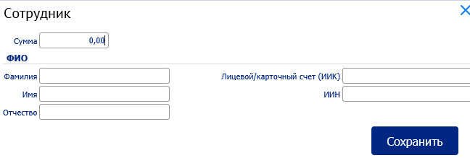
Figure 18

6.3. Creation of pension payment
To create a pension payment:

1. In the list form of payment documents, press the Create button on the toolbar and select the Pension payment in the drop-down list.
2. This will open the Pension payment window.
A number of fields in the window will be already filled in by the system. Fields with white background are filled in or edited manually. Fields with grey background are filled in either by the user by selecting values from the list, or automatically by the system (particularly after filling in the related fields). Filling in the Pension payment details is similar to the "Payment order/Payment to budget" form, which is described in sub-paragraph 2 of paragraph 6.1. Chapter 6 Payment documents.
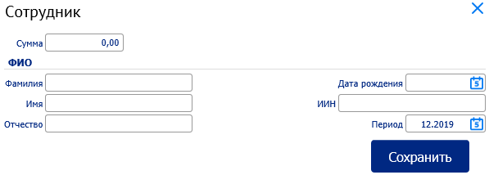
Figure 19
In the Employees box, enter information about employees for whom pension contributions are paid, and about the amount of payments to each of them:
A. Press the Add button in the box's toolbar.
B. This will display the window of entering information about the employee.
In this window:
1. In the Last name field, enter the last name of the employee.
2. In the First name field, enter the first name of the employee.
3. In the Patronymic field, enter the patronymic of the employee if necessary.
4. In the Amount field, enter the amount of payment to this employee.
5. Date of birth of the employee
6. In the IIN field, enter the IIN of this employee.
7. Save a record about the employee:
a. Press the Save button.
b. The system will check if the fields are filled in correctly, after that:
• If there are no errors or comments, you will be returned to the Pension payment window. The record about the employee will appear in the table of the Employee box.
• If there are errors and/or warnings, the Verification results window will be displayed.
After that, save, sign and send the created document to the bank by pressing on the Sign and Send button.

6.4. Creation of social payment
To create a social payment:

1. In the list form of payment documents, press the Create on the toolbar and select the Social payment in the drop-down list.
2. This will open the Social payment window.
A number of fields in the window will be already filled in by the system. Fields with white background are filled in or edited manually. Fields with grey background are filled in either by the user by selecting values from the list, or automatically by the system (particularly after filling in the related fields).
Filling in the Social payment details is similar to the "Payment order/Payment to budget" form, which is described in sub-paragraph 2 of paragraph 6.1. Chapter 6 Payment documents.
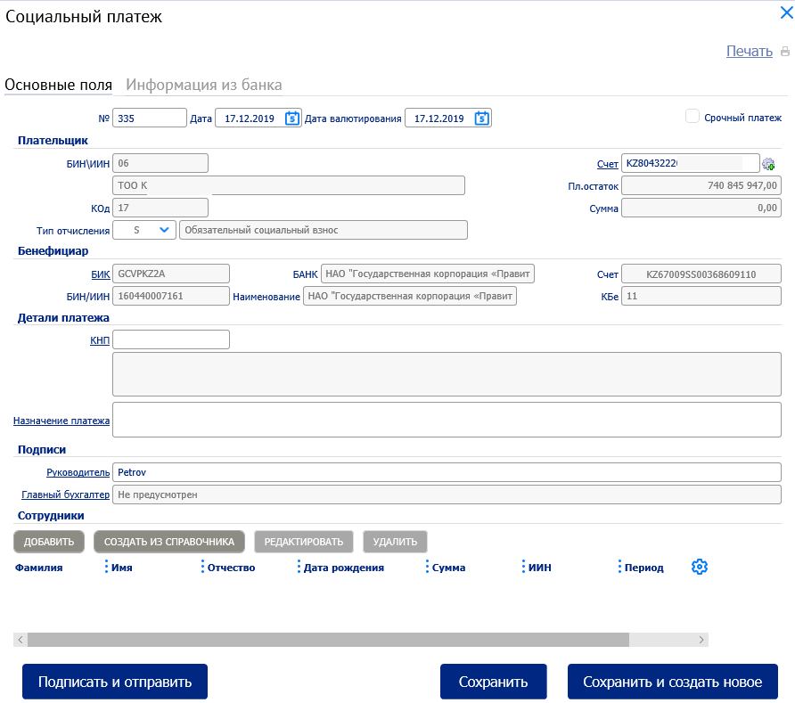
Figure 20
In the Employees box, enter information about employees for whom pension contributions are paid and about the amount of payments to each of them:
A. Press the Add button in the box's toolbar.
B. This will display the window of entering information about the employee.
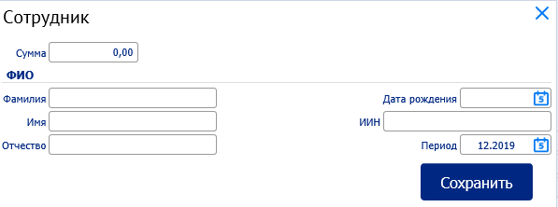
Figure 21
In this window:
1. In the Last name field, enter the last name of the employee.
2. In the First name field, enter the first name of the employee.
3. In the Patronymic field, enter the patronymic of the employee if necessary.
4. In the Amount field, enter the amount of payment to this employee.
5. Date of birth of the employee
6. In the IIN field, enter the IIN of this employee.
7. Payment period
Save a record about the employee:
a. Press the Save button.
b. The system will check if the fields are filled in correctly, after that:
• If there are no errors or comments, you will be returned to the Social Payment window. The record about the employee will appear in the table of the Employee box.
• If there are errors and/or warnings, the Verification results window will be displayed.
After that, save, sign and send the created document to the bank by pressing on the Sign and Send button.

6.5. Import of documents
The procedure of importing documents is universal for all import formats and types of imported documents, therefore the description of import of documents is given on the example of payment documents.
Import of payment orders is performed as follows:
1. In the main menu, select the "Payment documents".
2. In the opened list form on the toolbar, follow the "Import" link.

Document import window
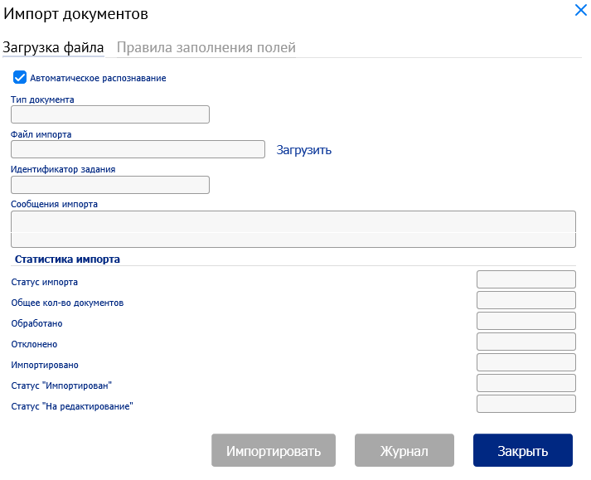
Figure 22
In the opened window if necessary to manually determine the type of the imported document and the instructions of filling in the fields of the document based on the import file, as well as to configure the control of duplicates, deselect the Automatic recognition selection field. After that:
a. In the Document type selection list, select the required document type to be imported.
b. Check the required import options on the Field fill-in instructions tab.
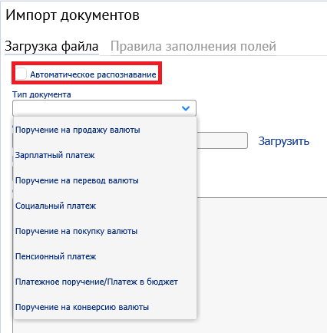
Figure 23
IMPORTANT!!! If you get an error when importing the document
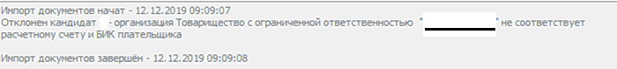
Figure 24
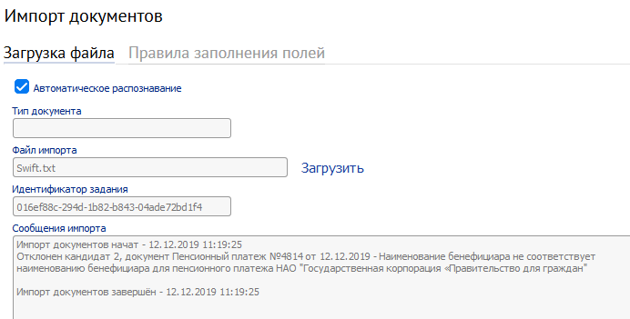
Figure 24.1
It is necessary to uncheck the options "Fill in the payer's name from the import file" and "Fill in the payer's IIN/BIN from the import file" in the "Field fill-in instructions" tab and check the option "Fill in the correspondent's details from the system configuration (for social and pension payments)".
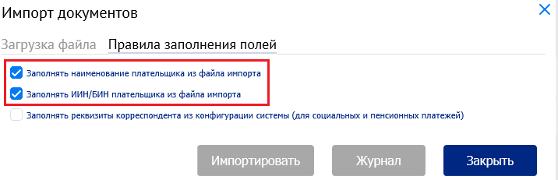
Figure 25
Then press "Download" to select the required import file. Import the file by pressing the "Import" button. When importing the file, the same verification will be applied to all the details to be filled as in the case of manual generation of the document.

Chapter 7. Foreign exchange transactions

7.1. Creation of currency purchase order

To create and send currency purchase orders for processing, select the option "Foreign exchange transactions" - "Currency purchase order" in the "Main menu".

To create a currency purchase order:
- In the list form of currency purchase orders press "Create" button in the toolbar.
- This will open the "Currency purchase" window.
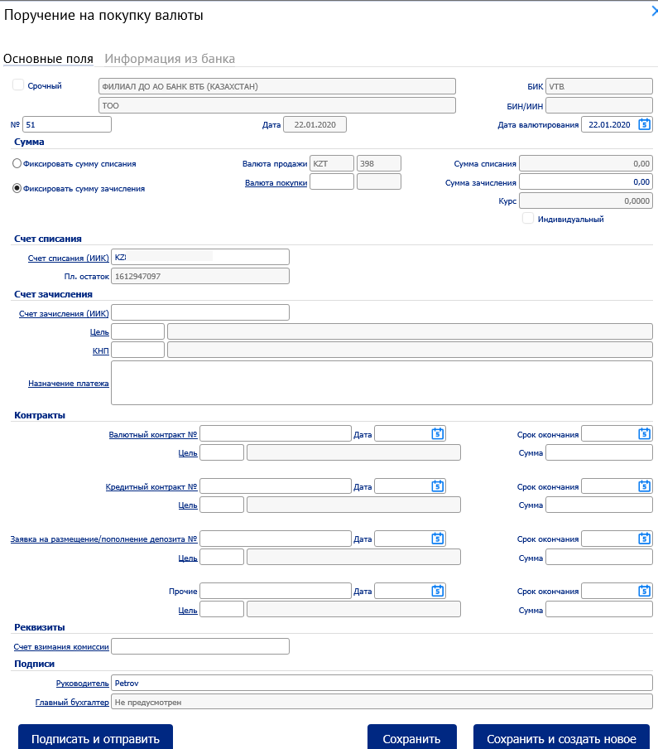
Figure 26

A number of fields in the window will be already filled in by the system. Fields with white background are filled in or edited manually. Fields with grey background are filled in either by the user by selecting values from the list, or automatically by the system during the filling in of document details.

- Enter or edit the values of currency purchase order details:
Note:
In case of application of "Individual rate" it is necessary to choose the option "Individual rate" and in the "Rate" field, enter the amount of the individual rate for sending an order to the Bank and further agreement of the individual rate.

- In the "Number" field, change the document number if necessary. By default, the system numbers the documents in the order they were created during the calendar year.
- In the "Date" field, change the date of the document if necessary. By default, the field is filled in with the current date.
- Enter the method for calculating the amounts to be converted by checking the appropriate field in the "Amount" box of selection fields: Fix the amount to be debited or Fix the amount to be credited.
- In the "Purchase currency" field box, select the purchase currency from the directory.
- Enter the amount to be converted:
• If you selected Fix the amount to be debited, enter the appropriate amount in the Debited amount field.
• If you selected to Fix the amount to be credited, enter the appropriate amount in the Credited amount field.
Note
The second of these amounts will be automatically calculated and displayed in the appropriate field after entering the conversion rate.

- In the Rate field, the standard rate is automatically displayed.
- In the Debited account (IIC) field of the Debited account box, select the debited account number from the directory.
- In the Credited account box, select the credited account details:
- In the Credited account (IIC) field, select the credited account number from the directory.
- In the Payment purpose code field, select the number from the payment purpose code directory.
- If necessary, change the value in the Payment purpose field.
- In the fee Charged account field of the Details box, select a fee charged account from the directory.
- In the Signatures box, the Manager field is available for selecting signatories with the General Director position. By default, the field is filled in with the first record with this position in the directory.
The Chief Accountant field is available for selecting signatories with the Chief Accountant position. By default, the field is filled in with the first record with this position in the directory. If one of the records of the position is missing, the field will be automatically filled in with the "Not provided" value.
n) to save, sign and send the created order to the bank, press the "Sign and send" button.

7.2. Generation and sending of currency selling orders for processing

To generate and send currency selling orders for processing, select the Foreign exchange transactions – Currency selling order option in the Main menu

To create a currency selling order:
- In the list form of currency selling orders press Create button in the toolbar.
- This will open the Currency selling window.
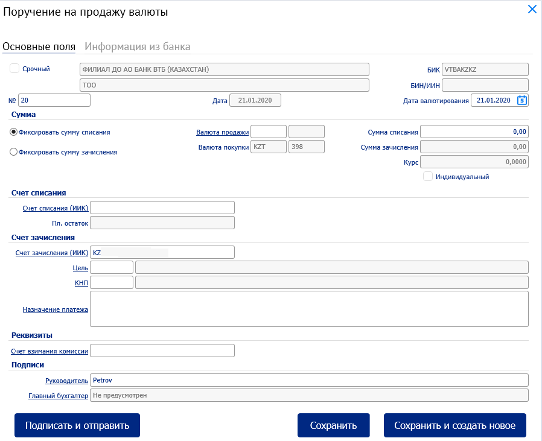
Figure 27

A number of fields in the window will be already filled in by the system. Fields with white background are filled in or edited manually. Fields with grey background are filled in either by the user by selecting values from the list, or automatically by the system during the filling in of document details.

- Enter or edit the values of currency selling order details:
Note:
- In case of application of "Individual rate", it is necessary to choose the option "Individual rate" and in the "Rate" field, enter the amount of the individual rate for sending an order to the Bank and further agreement of the individual rate in the Number filed, if it is necessary to change the document number. By default, the system numbers the documents in the order they were created during the calendar year.
- In the Date field, change the date of the document if necessary. By default, the field is filled in with the current date.
- Enter the method for calculating the amounts to be converted by checking the appropriate field in the Amount box of selection fields: Fix the amount to be debited or Fix the amount to be credited.
- In the Selling currency field box, select the selling currency from the directory.
- Enter the amount to be converted:
• If you selected Fix the amount to be debited, enter the appropriate amount in the Debited amount field.
• If you selected to Fix the amount to be credited, enter the appropriate amount in the Credited amount field.
Note
The second of these amounts will be automatically calculated and displayed in the appropriate field after entering the conversion rate.

- In the Rate field, the standard rate is automatically displayed.
- In the Debited account (IIC) field of the Debited account box, select the debited account number from the directory.
- In the Credited account box, select the credited account details:
- In the Credited account (IIC) field, select the credited account number from the directory.
- In the Payment purpose code field, select the number from the payment purpose code directory.
- If necessary, change the value in the Payment purpose field.
- In the fee Charged account field of the Details box, select a fee charged account from the directory.
- In the Signatures box, the Manager field is available for selecting signatories with the General Director position. By default, the field is filled in with the first record with this position in the directory.
The Chief Accountant field is available for selecting signatories with the Chief Accountant position. By default, the field is filled in with the first record with this position in the directory. If one of the records of the position is missing, the field will be automatically filled in with the "Not provided" value.
n) to save, sign and send the created order to the bank, press the "Sign and send" button.

7.3. Generation and sending of currency conversion orders for processing

To generate and send currency conversion orders for processing, select the Foreign exchange transactions – Currency conversion order option in the Main menu

The procedure for creating a conversion order, execution and acceptance/sending is similar to the procedure for creating a currency purchase/selling order, according to the sub-paragraphs 7.1-7.2. Guides

7.4. Generation and sending of currency transfers for processing
To create a Currency transfer, select Currency transfer order in the Main menu.
This will open the Currency transfer order window.
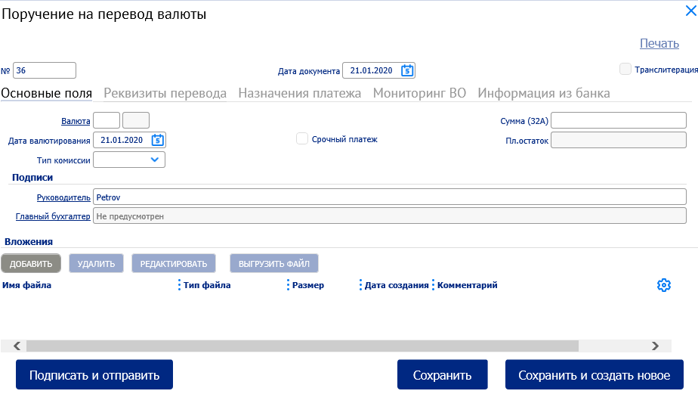
Figure 28
A number of fields in the window will be already filled in by the system. Fields with a white background are filled in or edited manually. Fields with grey background are filled in either by the user by selecting values from the list, or automatically by the system during the filling in of document details.
Enter the details value:
- In the general part of the "Currency transfer order" window, enter the main details of the document:
- In the "Number" field, change the document number if necessary. By default, the system numbers the documents in the order they were created during the calendar year.
- In the "Document date" field, change the document date if necessary. By default, the field is filled in with the current date.
- If necessary, fill in the "Transliteration" selection field. If the field is filled in, the system makes sure that only Latin alphabet characters are entered into ED fields.
- In the open Main fields tab of the Currency transfer order window, enter the main information about the transfer:
- Enter the transfer currency:
- In the Currency box, enter manually the first field on the left or select the three-letter code of the transfer currency from the directory.
- The fields will be filled in automatically:
• The right field of the Currency box – numeric code of the currency.
• Value date field – current date.
• If transliteration is used for the specified currency, the Transliteration selection field will also be filled in.

Note
If the "Transliteration" field is filled in, the system makes sure that only the Latin alphabet characters are entered in the document fields.

- If necessary, change the value in the Value date field by entering the required value date (not earlier than the current date).
- In the Fee type field, indicate the method of charging the transfer fee by selecting the appropriate fee type from the directory:
• If the expenses are paid by the beneficiary, select the BEN.
• If the expenses are paid by both parties, select the SHA.
• If the expenses are paid by the payer, select the OUR.

- If it is necessary to make an urgent payment:
- Fill in the Urgent payment selection field.
- The Value date field will be automatically filled in with the current date and will not be available for editing.
- In the Amount (32A) field, enter the amount of transfer.
- In the Manager field, signatories with the General Director position are available for selection. By default, the field is filled in with the first record with this position in the directory.
The Chief Accountant field is available for selecting signatories with the "Chief Accountant" position. By default, the field is filled in with the first record with this position in the directory. If there are no records with this position, the field will be automatically filled in with the "Not provided" value and will not be available for editing.
- If necessary, attach the attachment files to the document in the Attachments box.

Follow the Transfer details tab of the Currency transfer order window to enter the details of the sender, beneficiary and banks involved in the transfer processing.
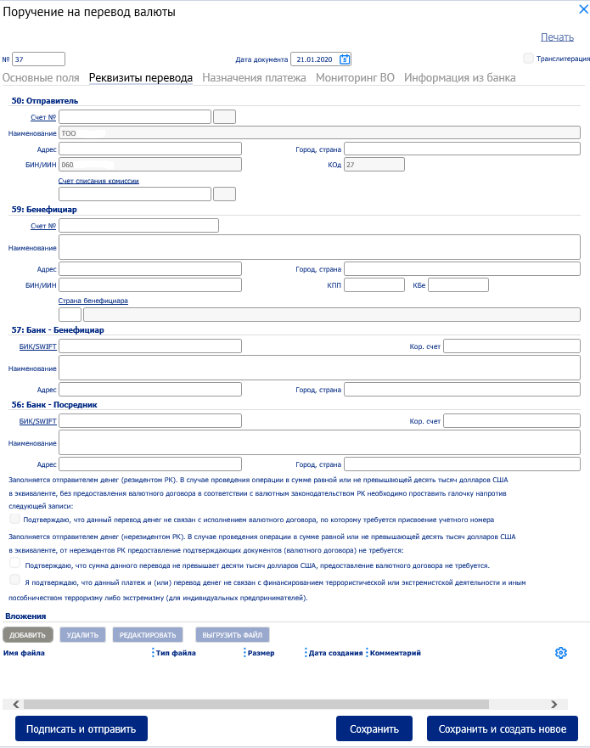
Figure 29

- In the 50: Sender box, enter or edit the values of the payer's details:
  - In the Account No. (payer's account) field, select the payer's currency account number from the directory. If the payer has one currency account, the field will be filled in automatically.
  - If you select an account from the Name, Address, City, Country, BIN/TIN, Code directory, as well as the Planned balance field, the Main fields tab are filled in automatically. If no values are available, enter the city, country and address of the payer in the appropriate fields.
- In the 59: Beneficiary box, enter the values of the recipient's details and the appropriate banks using one of the following methods:
• If the information about the recipient was previously entered in the foreign beneficiary directory:
1. Select the required record about the beneficiary from the foreign beneficiary directory.
2. The Account No., Name, Address, City, Country, BIN / TIN, Country of residence, Registration reason code, Beneficiary code fields and similar fields in the 57: Beneficiary Bank box (and with the participation of the intermediary bank, and the 58: Intermediary bank box) as well as the fields of the Beneficiary's country box will be filled with the values from the directory.
• If data on the beneficiary has not been previously entered in the foreign beneficiary directory (new beneficiary), please enter the details of the beneficiary manually:
- In the Account No. field, enter the beneficiary's account number.
- In the Name field, enter the name of the beneficiary organization.
- In the City, country field, enter the name of the city and indicate the country where the beneficiary is registered.
- In the Address field, enter the address to which the beneficiary is registered.
- In the BIN / TIN field, enter the beneficiary's BIN / TIN.
- In the Registration reason code field, enter the beneficiary's registration reason code (if any).
- In the Beneficiary code field, enter the beneficiary code.
- In the fields of the Beneficiary's country box, select the Beneficiary's country from the country directory or manually enter the code and name of the country of residence of the beneficiary.
- If the values of the beneficiary's details were filled in from the foreign beneficiary directory, the fields in 57a: Beneficiary bank and 56а: Intermediary bank boxes can be automatically filled in with the values from the directory. Enter / edit if necessary, the values of the details of the bank serving the beneficiary, and if necessary, the intermediary bank - the details of the intermediary bank:
1. In the 57: Beneficiary bank box, enter the details of the beneficiary bank:
a. In the BIC / SWIFT field select from the directory of foreign banks or enter manually the SWIFT code of the beneficiary bank.
b. The rest of the box fields can be filled in automatically.
c. In the field Correspondent account, if necessary enter / change the correspondent account of the beneficiary bank opened in the intermediary bank.
d. In the Name field, if necessary enter / change the full name of the beneficiary bank.
e. In the Address field, if necessary enter / change the address at which the beneficiary bank is registered.
f. In the City, country field, if necessary enter / change the name of the city and, using the country directory, indicate the country where the beneficiary bank is located.
2. In the 58: Intermediary bank box, enter the details of the intermediary bank if necessary.

Note
Details of the intermediary bank are indicated if the Correspondent account field is filled in the 57: "Beneficiary bank" box.
a. In the "BIC / SWIFT" field select from the directory of foreign banks or enter manually the SWIFT code of the intermediary bank.
b. The rest of the box fields can be filled in automatically.
c. In the "Correspondent account" field, enter / change the correspondent account of the intermediary bank if necessary.
d. In the "Name" field, enter / change the full name of the intermediary bank if necessary.
e. In the "Address" field, if necessary enter / change the address at which the intermediary bank is registered.
f. In the "City, country" field if necessary enter / change the name of the city and, using the country directory, indicate the country where the intermediary bank is located.
3. If the amount of the transaction does not exceed ten thousand US dollars, and the transfer is made without providing the currency agreement (or other document on the basis of which the payment is made), in the text box at the bottom of the tab, it is mandatory to check the appropriate confirmation record:
• If the organization in whose name the document is created is a resident of the Republic of Kazakhstan, check the first record.
• If the organization, in whose name the document is created, is a non-resident of the Republic of Kazakhstan - check the second record.

4. Fill in the payment information:

- Follow the Payment purpose tab of the Currency transfer order window.
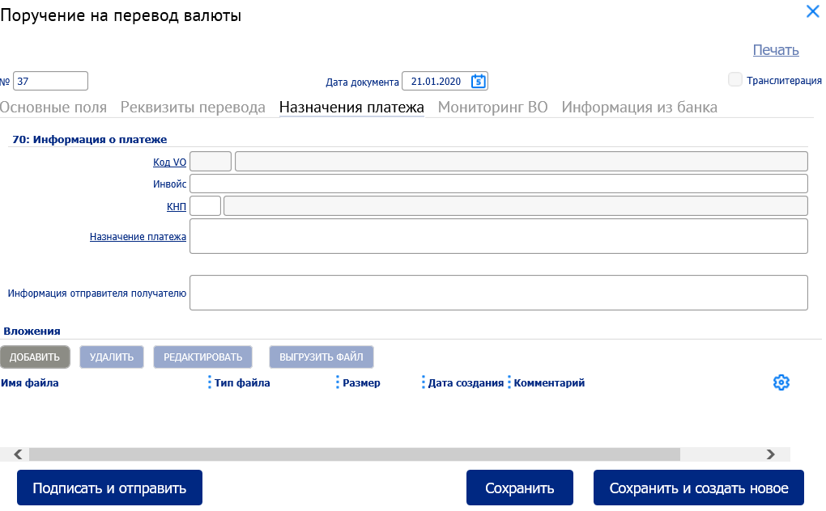
Figure 30

5. In the 70: Payment information box, enter the detailed information about the payment:
1) If the transfer currency is "RUB" in the CT code field, enter manually or select the appropriate foreign exchange transaction code from the CT code directory.
2) In the Invoice field, enter the invoice number.
3) In the Payment purpose code field, select a value from the directory or enter it manually.
4) In the Payment purpose field, enter the payment purpose if necessary.
5) In the Sender information field, enter a message for the transfer recipient if necessary. 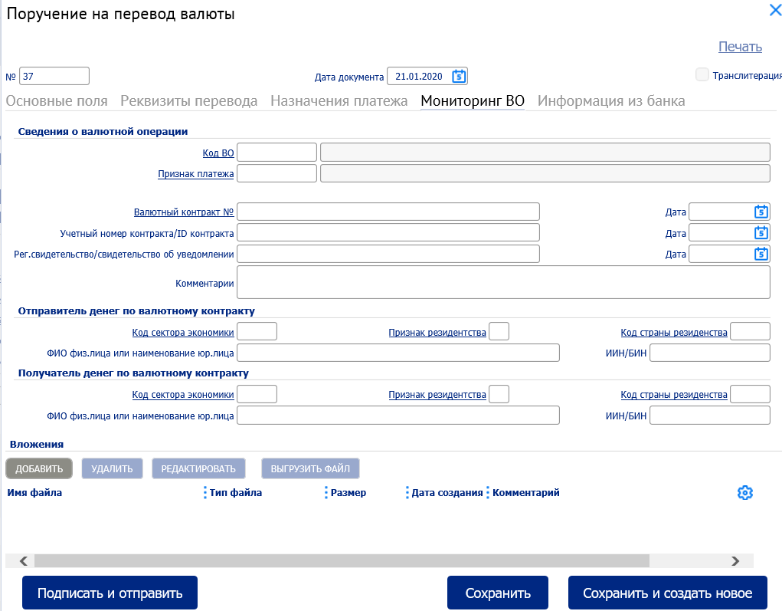
Figure 31

Information about foreign exchange transaction in the "CT monitoring" tab is reflected on the basis of primary documents of the client.
The import procedure of "Currency transfer orders" is similar to the import procedure of "Payment documents" in accordance with paragraph 6.5. "Import of documents" Chapter 6. "Payment documents".

Chapter 8. Covered guarantees (under development)
The functionality of the "Covered guaranties" option is currently under development.

Chapter 9. Foreign exchange contracts (under development)
The functionality of the option "Foreign exchange contracts" is currently under development.

Chapter 10. Credit documents (under development)
The functionality of the "Credit documents" option is currently under development.

Chapter 11. Letters to the bank

11.1. Letters to the bank
Viewing of letters to the bank for the selected period (set a date) with the possibility of exporting the list to XLS format
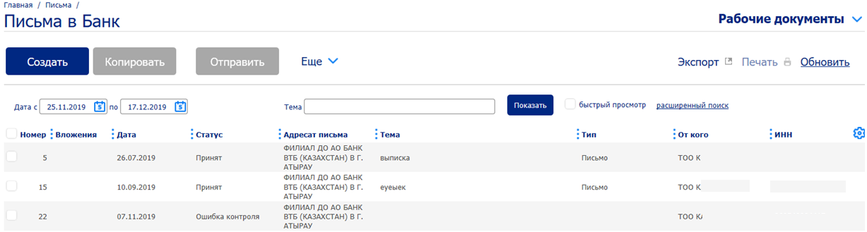
Figure 32
Form a letter to the bank through "Create".
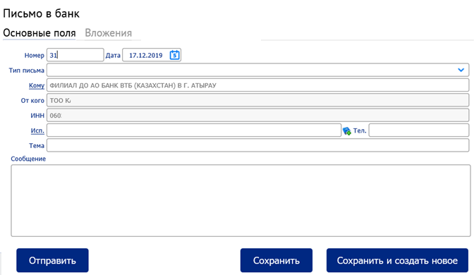
Figure 33
A number of fields in the window will be already filled in by the system. Fields with white background are filled in or edited manually. Fields with grey background are filled in either by the user by selecting values from the list, or by the system during filling in the related fields.
Attachment of files to an e-mail via the "Attachment" tab is within the allowed size per one file. Sending an email to the bank via the "Send" option.
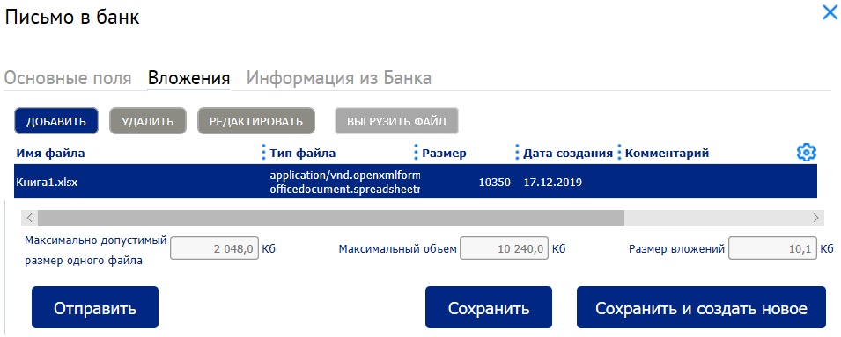
Figure 34

11.2. Letters from the bank
Letters from the bank are viewed in the same way as letters to the bank, with the ability to export the list to XLS format.

